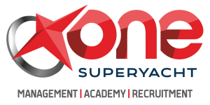 Certificate Number : {certNo}

Certificate of Completion
{courseTitle}

This is to certify that Mr. / Ms. : {fullName}
Date of birth : {dob}
National ID/Passport No : {passportNumber}

Has successfully completed training of “{courseTitle}” at Xone Superyacht Academy, approved by the Merchant Shipping Directorate of the Authority for Transport in Malta as meeting the requirements laid down in

- {courseRegulations}

Principal (or Authorised Representative) Xone Superyacht Academy
Name : {instructorName} | Name : Dr. Emin Cihan Duyan
Date : {issueDate} Date : {issueDate}
Signature : Signature :

Xone Superyacht Academy Skyway Offices, Block C Number 2, 179 Marina Street, Pieta, Malta, PTA 9042
+356 9910 4901 malta@xoneyacht.com

